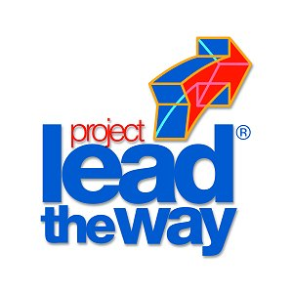
Project 2.1.1 – Getting Started

Purpose
Wouldn’t it be great if every class you took had an obvious impact on the rest of your life? This course is designed to do just that. You will be completing a research and design project that most students don’t have the opportunity to do until college. Your instructor will become your guide mentor perhaps, but certainly your #1 cheerleader.

You may have already realized that in a work environment the supervisor trains employees to do certain tasks and then expects them to complete the tasks. He or she lays out milestones and timelines in much the same way you will do in this class. Some information you will be able to collect on your own, but other information you will have to consult individual experts for their opinions.

Equipment
- Engineer’sNotebook
- Rule of Thirds Handout
- 10 Mighty Questions Handout
- Project Flow Chart

Procedure
In this project, you are going to evaluate the components or steps that will guide you in writing your problem statement and ultimately affect the rest of your EDD project. Pay close attention to the answers to the conclusion questions because you will refer back to them in the days ahead.

Looking at the Project Flow Chart and 10 Mighty Questions handout, answer the conclusion questions in your engineer’s notebook.

After you have categorized the conclusion questions, review the Rule of Thirds handout to check your accuracy.

Conclusion
- Which of the 10 mighty questions will have to be researched to find the answers?

- Which of the 10 mighty questions will require you to design and build something to find the answers?

- Which of the 10 mighty questions require testing and analysis to answer?

